## df_alzheimer

precision recall f1-score support

0 0.00 0.00 0.00 4

1 0.91 0.95 0.93 171

2 0.66 0.58 0.61 33

3 0.00 0.00 0.00 1

micro avg 0.87 0.87 0.87 209

macro avg 0.39 0.38 0.39 209

weighted avg 0.85 0.87 0.86 209

[[ 0 3 1 0]

[ 0 162 8 1]

[ 0 13 19 1]

[ 0 0 1 0]]

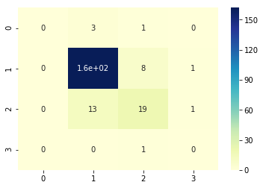

## df_cancer

precision recall f1-score support

0 0.58 0.28 0.38 25

1 0.78 0.92 0.84 121

2 0.57 0.41 0.47 32

3 0.20 0.20 0.20 5

micro avg 0.72 0.72 0.72 183

macro avg 0.53 0.45 0.47 183

weighted avg 0.70 0.72 0.70 183

[[ 7 13 4 1]

[ 4 111 4 2]

[ 1 17 13 1]

[ 0 2 2 1]]

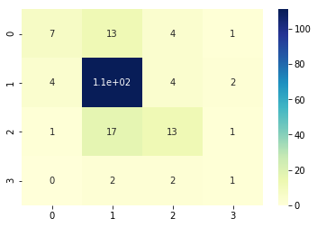

## df_depression

precision recall f1-score support

0 0.62 0.38 0.47 21

1 0.61 0.66 0.64 83

2 0.00 0.00 0.00 5

3 0.55 0.58 0.56 59

micro avg 0.58 0.58 0.58 168

macro avg 0.44 0.40 0.42 168

weighted avg 0.57 0.58 0.57 168

[[ 8 9 1 3]

[ 4 55 1 23]

[ 0 3 0 2]

[ 1 23 1 34]]

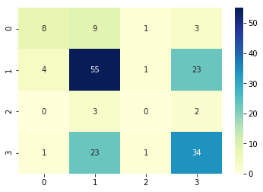

## df_heart_attack

precision recall f1-score support

0 0.80 0.88 0.84 110

1 0.78 0.68 0.72 31

2 0.71 0.31 0.43 16

3 0.12 0.17 0.14 6

micro avg 0.76 0.76 0.76 163

macro avg 0.60 0.51 0.54 163

weighted avg 0.76 0.76 0.75 163

[[97 5 1 7]

[ 9 21 1 0]

[10 1 5 0]

[ 5 0 0 1]]

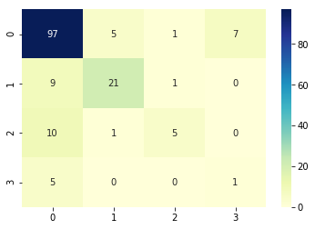

## df_parkinson

precision recall f1-score support

0 0.90 0.73 0.81 37

1 0.90 0.90 0.90 106

2 0.52 0.85 0.65 13

3 1.00 0.67 0.80 3

micro avg 0.85 0.85 0.85 159

macro avg 0.83 0.78 0.79 159

weighted avg 0.87 0.85 0.85 159

[[27 8 2 0]

[ 3 95 8 0]

[ 0 2 11 0]

[ 0 1 0 2]]

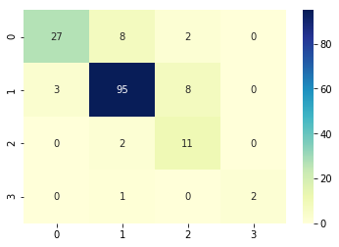

## df_stroke

precision recall f1-score support

0 0.79 0.92 0.85 98

1 0.90 0.68 0.77 53

2 0.62 0.65 0.64 23

3 0.00 0.00 0.00 4

micro avg 0.79 0.79 0.79 178

macro avg 0.58 0.56 0.57 178

weighted avg 0.78 0.79 0.78 178

[[90 3 5 0]

[14 36 3 0]

[ 7 1 15 0]

[ 3 0 1 0]]

